Sunny Valley Studio Tutorials

Top-Down Tanks Game

Things I Learned

* 2D Tile Map.
* I now learned how to create and use Unity Events.
* Instructor used Mathf.Atan2 to calculate desired angle and there is also Mathf.Atan function available so need to figure out why used the Atan2.
* Input.GetAxis Gets a range of values between -1 and 1 and it is based on sensitivity which is why when we press W or A or S or D, the tank moves in that direction but keeps on moving and the solution for this is using Input.GetAxisRaw instead as that only gets values -1 and 1 which will make the tank stop as soon as we let go of the buttons.
* Very useful Collision Action Matrix of Documentation.
* Object Pool Design Pattern through Queue Data Structure.
* Separation of data from behaviours using Scriptable Objects
* Physics2D Settings Unchecking Queries Start in Colliders to disable detecting itself.
* Usage of internal keyword.
* Usage of Vector2.Angle which returns angle between two Vector2 positions and return type is a float.
* Strategy Pattern: The picture below has the illustration of the concept. The context in our case will be Default Enemy Behaviour, Strategy is an interface and, in our case, an abstract class and the algorithm is PerformAction(). Strategy abstract class defines what our AI should do and the context doesn’t know or care what the strategy is. This is very flexible because we can then create another different behaviour without too much code.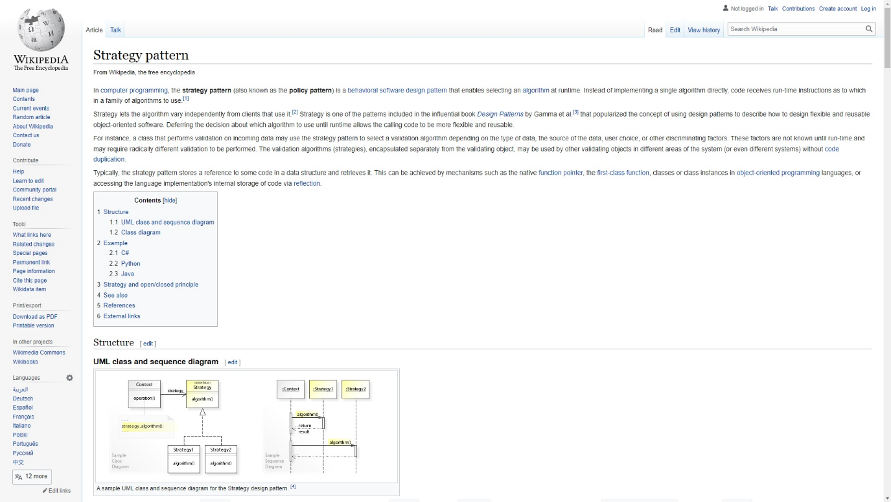
* Patrol Path creates a triangle so to fix that, add second point which is B as the 4th one in the list. Not sure why though.
* var minDistance = float.MaxValue; Not sure what this means.